John Michael Go
Career Entry Level Java Programming
Date: Jan. 11, 2013

DAY 1

Program Name: Payroll2

Objective: Program calculates monthly salary with absents and deductions. Will also reduce tax deduction for senior citizen employees.

Algorithm:

- User inputs name.
- User inputs age.
- User inputs dept.
- User inputs days absent
- Program calculates Salary details, deductions and Salary computation but will have an additional pay for senior citizen absences.

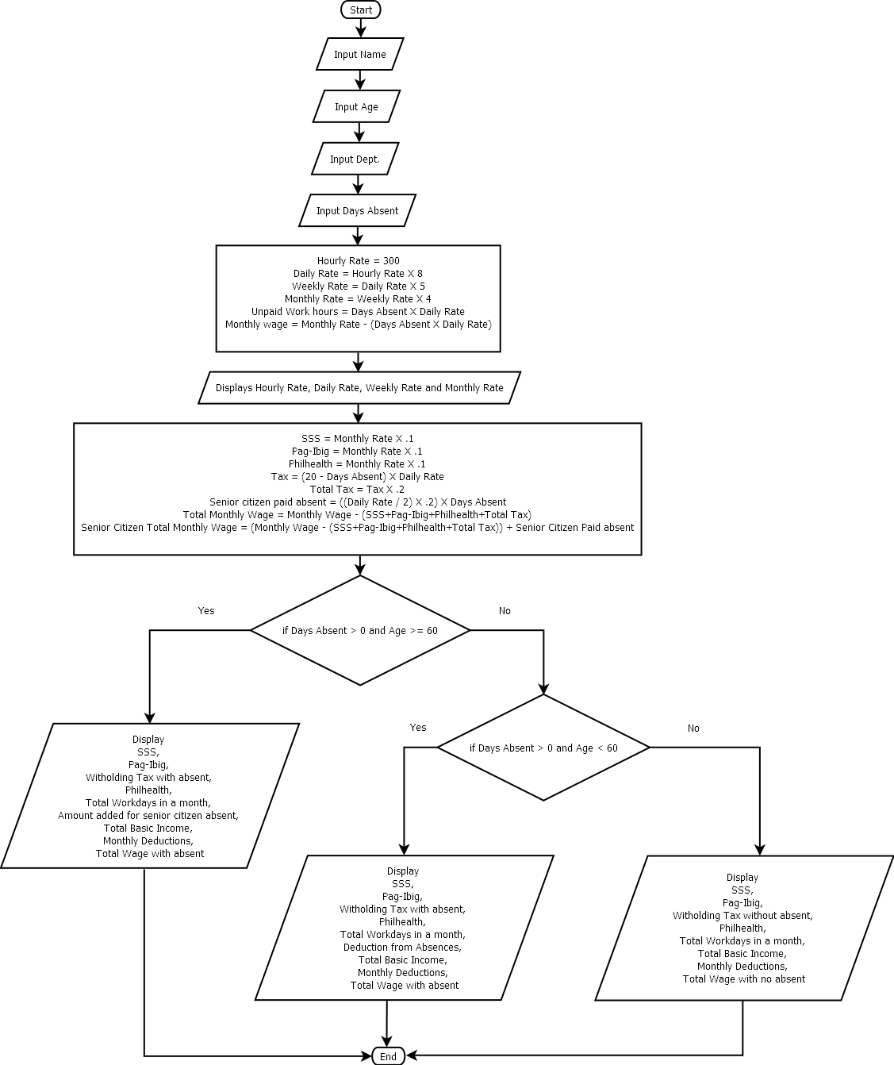
Flowchart:

Pseudocode:

import java.util.*;

public class Payroll2{

static Scanner console = new Scanner (System.in);

public static void main(String[]args){

// variable declaration
String name, dept;
int age, abs, hour;
double day, week, month, wage, sss, pbg, tax, ttax, phl, twage1, twage2, tabs, dsen, asen, tasen;

// input data
System.out.println ("");
System.out.print("Enter your name: ");
name = console.next();
System.out.println ("");
System.out.print("Enter your age: ");
age = console.nextInt();
System.out.println ("");
System.out.print("Enter your dept: ");
dept = console.next();
System.out.println ("");
System.out.print("Days absent: ");
abs = console.nextInt();
System.out.println("");

// salary rate computation
hour = 300;
day = hour * 8;
week = day * 5;
month = week * 4;
tabs = abs*day;
wage = month - tabs;

// displays employee details
System.out.println ("===============================================================================");
System.out.println("");
System.out.println("Employee Details:");
System.out.println("");
System.out.println("Name : " +name);
System.out.println("Age : " +age);
System.out.println("Dept.: " +dept);
System.out.println("");

// displays salary details
System.out.println("Salary Details:");
System.out.println("");
System.out.println("Your Hourly Rate is : 300.00");
System.out.println("Your Daily Rate is : " + String.format("%.2f", day));
System.out.println("Your Weekly Rate is : " + String.format("%.2f", week));
System.out.println("Your Monthly Rate is : " + String.format("%.2f", wage));

// deduction and wage computation
sss = wage * .10;
pbg = wage * .10;
phl = wage * .10;
tax = ((20-abs) * day);
ttax = tax * .20;
asen= (day/2) * .20;
tasen = asen * abs;
twage1 = wage - (pbg+sss+phl+ttax);
twage2 = ((wage - (pbg+sss+phl+ttax))+tasen);

// displays deductions
System.out.println("");
System.out.println("Deductions:");
System.out.println("");

// with absent and senior citizen
if (abs > 0 && age>=60){
System.out.println("SSS : " + String.format("%.2f", sss));
System.out.println("Pag-Ibig : " + String.format("%.2f", pbg));
System.out.println("Witholding Tax less " + abs + " absence/s : " + String.format("%.2f", ttax));
System.out.println("Philhealth : " + String.format("%.2f", phl));
System.out.println("");
System.out.println ("===============================================================================");
System.out.println("");
System.out.println("Salary Computation:");
System.out.println ("");
System.out.println ("Your Total Workday/s in a Month : " +(20-abs));
System.out.println ("");
System.out.println("Amount added for " + abs + " absence/s (SC) : " + String.format("%.2f", tasen));
System.out.println ("");
System.out.println("Your Total Basic Income : " + String.format("%.2f", wage+tasen));
System.out.println ("");
System.out.println("Less Monthly Deductions : " + String.format("%.2f", (pbg+sss+phl+ttax)));
System.out.println ("");
System.out.println("Your Total Wage with Absence/s : " + String.format("%.2f", twage2));
System.out.println ("");
System.out.println ("===============================================================================");
System.out.println("");
System.out.println("");
System.out.println("");
}else if (abs > 0 && age<60) {

// with absent but not senior citizen
System.out.println("SSS : " + String.format("%.2f", sss));
System.out.println("Pag-Ibig : " + String.format("%.2f", pbg));
System.out.println("Witholding Tax less " + abs + " absence/s : " + String.format("%.2f", ttax));
System.out.println("Philhealth : " + String.format("%.2f", phl));
System.out.println("");
System.out.println ("===============================================================================");
System.out.println("");
System.out.println("Salary Computation:");
System.out.println ("");
System.out.println ("Your Total Workday/s in a Month : " +(20-abs));
System.out.println ("");
System.out.println("Deduction from " + abs + " absence/s : " + String.format("%.2f", tabs));
System.out.println ("");
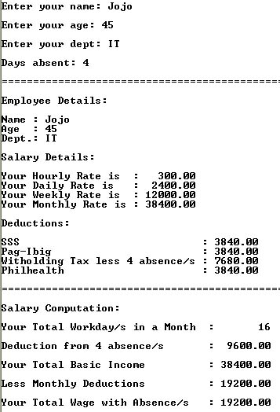
System.out.println("Your Total Basic Income : " + String.format("%.2f", wage));
System.out.println ("");
System.out.println("Less Monthly Deductions : " + String.format("%.2f", (pbg+sss+phl+ttax)));
System.out.println ("");
System.out.println("Your Total Wage with Absence/s : " + String.format("%.2f", twage1));
System.out.println ("");
System.out.println ("===============================================================================");
System.out.println("");
System.out.println("");
System.out.println("");
}else{

// no absences
System.out.println("You have no absences!");
System.out.println("");
System.out.println("SSS : " + String.format("%.2f", sss));
System.out.println("Pag-Ibig : " + String.format("%.2f", pbg));
System.out.println("Witholding Tax : " + String.format("%.2f", ttax));
System.out.println("Philhealth : " + String.format("%.2f", phl));
System.out.println("");
System.out.println ("===============================================================================");
System.out.println("");
System.out.println("Salary Computation:");
System.out.println ("");
System.out.println ("Your Total Workday/s in a Month : " +(20-abs));
System.out.println ("");
System.out.println("Your Total Basic Income : " + String.format("%.2f", wage));
System.out.println ("");
System.out.println("Less Monthly Deductions : " + String.format("%.2f", (pbg+sss+phl+ttax)));
System.out.println ("");
System.out.println("Your Total Wage : " + String.format("%.2f", twage1));
System.out.println ("");
System.out.println ("===============================================================================");
System.out.println("");
System.out.println("");
System.out.println("");
}

}

}

Screenshot:

